

University Of Engineering and Technology Taxila, Pakistan

**Mobile Application Development**

**Quiz# 02**

**Submitted By:**

Ayesha Akram

**Registration No:**

21-SE-34

**Submitted To:**

Ma’am Kanwal Yousaf

Few changes are applied to the Object Detection Model:

1. Navigation drawers for easy navigation
2. Navigation to Camera Screen after successful Sign In/Sign Up
3. Home Tab to help user discover the purpose of the app.

Few changes are applied to the QnA Model:

1. Navigation drawers for easy navigation
2. Navigation to QnA Screen after successful Sign In/Sign Up
3. Home Tab to help user discover the purpose of the app.
4. Animations added to the Home page for better UI experience.
5. ScrollView in objectDetectionScreen.js for enable the user to scroll.
6. Keyboard dismissal after the user has pressed Find Answer button to make the answer visible, instead of being wrapped by the keyboard.
7. Clear the answers when the user finds the answers of the next question.

Details to run the project are provided in the README.md

Github link:

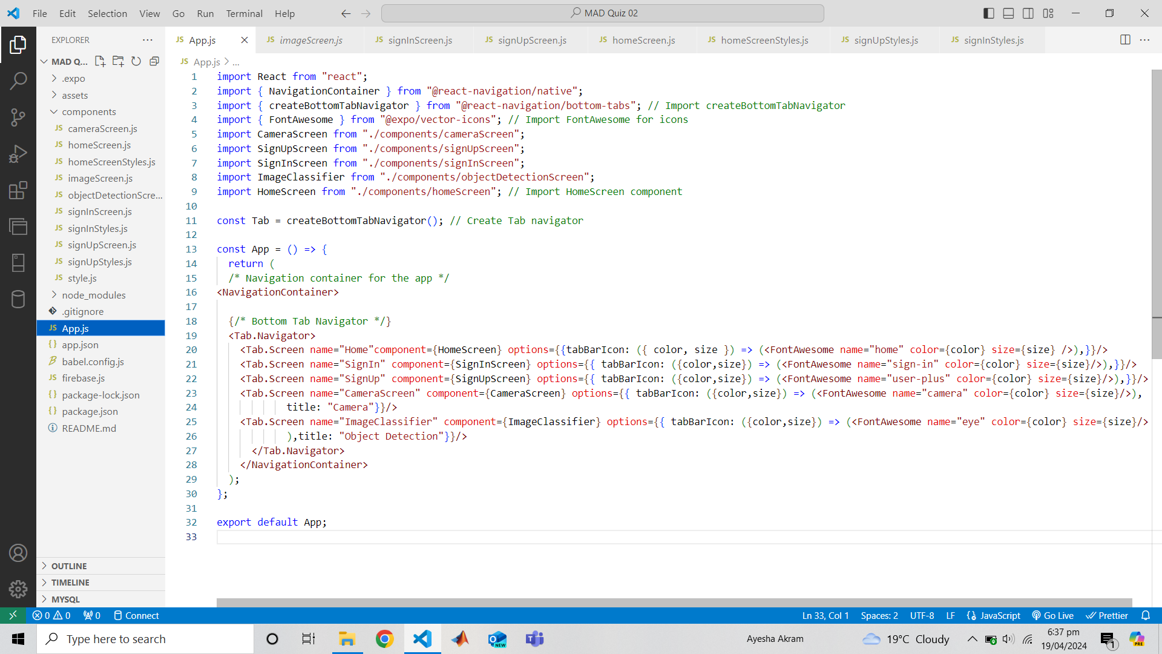**Codes of the Changes in Object Detection Model:**

**App.js**

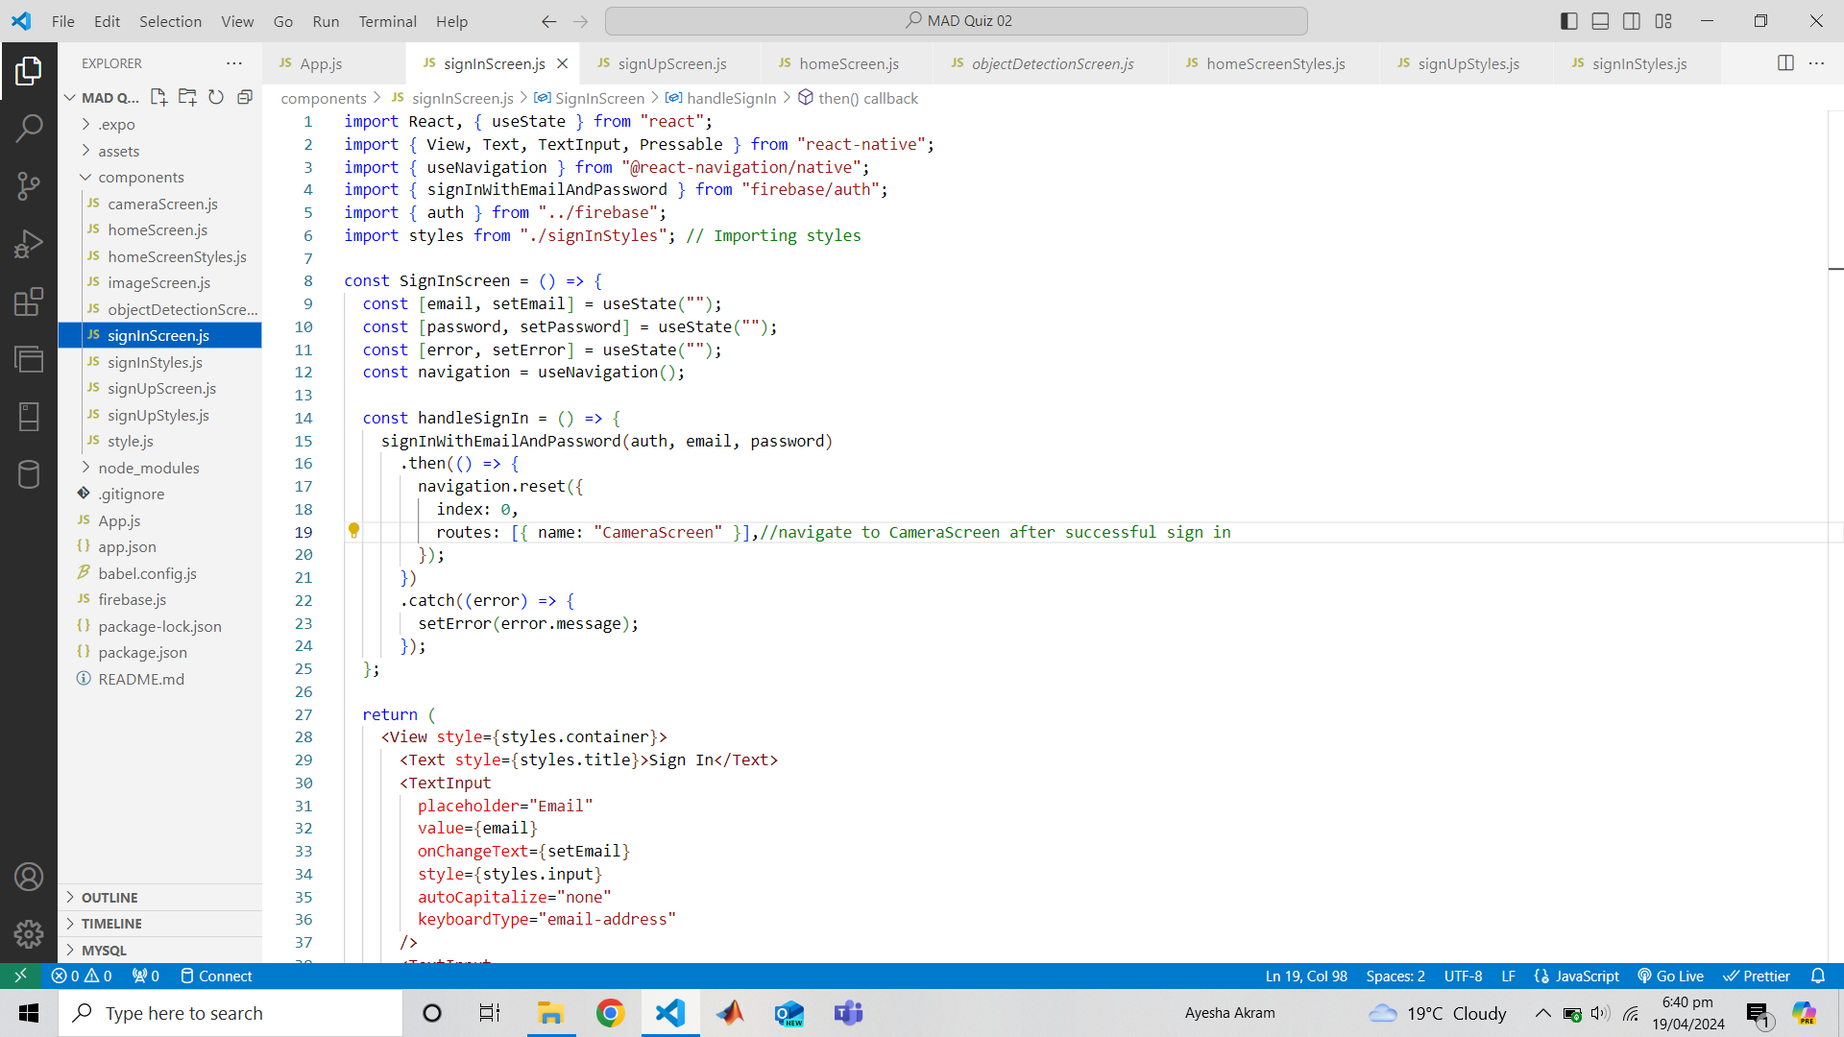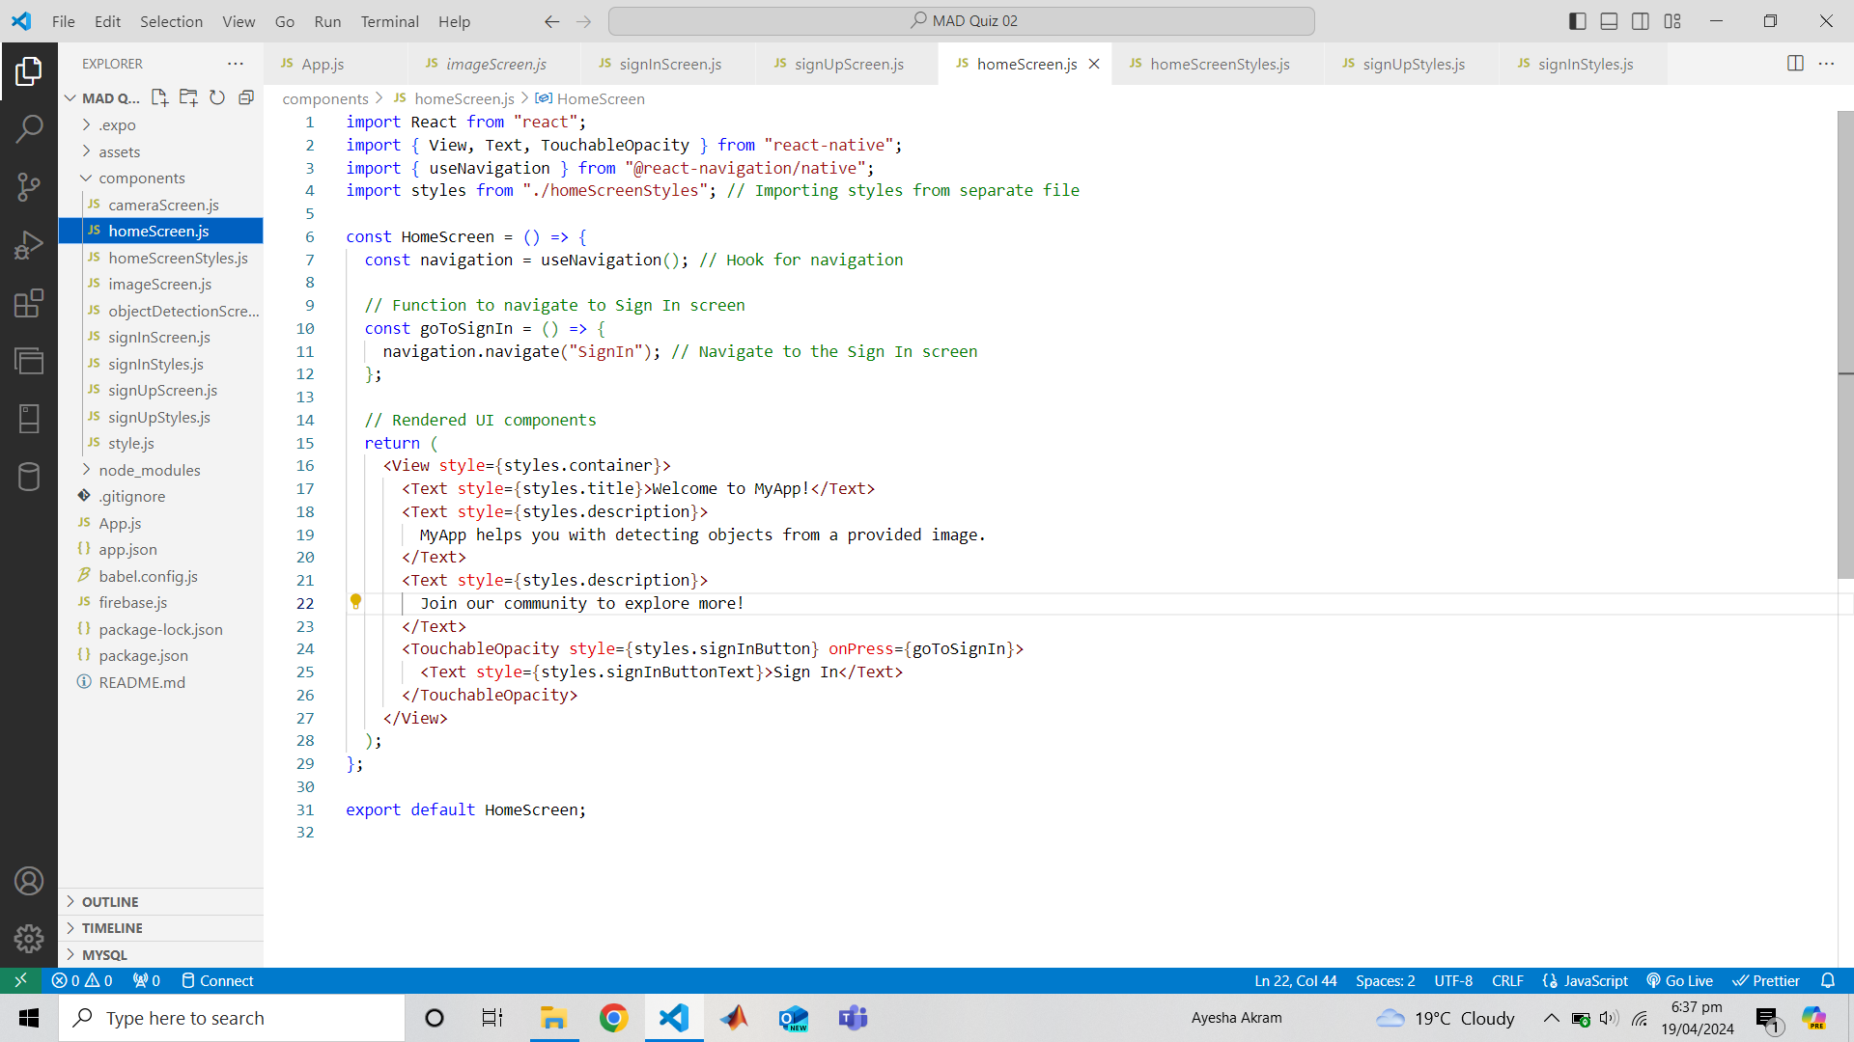

**homeScreen.js**

**signInScreen.js**

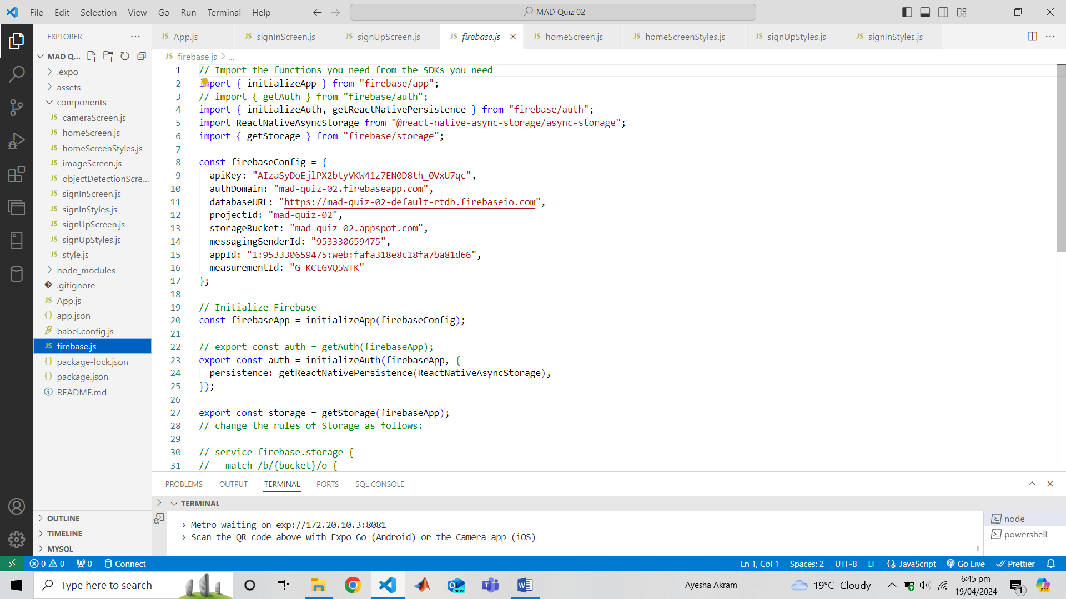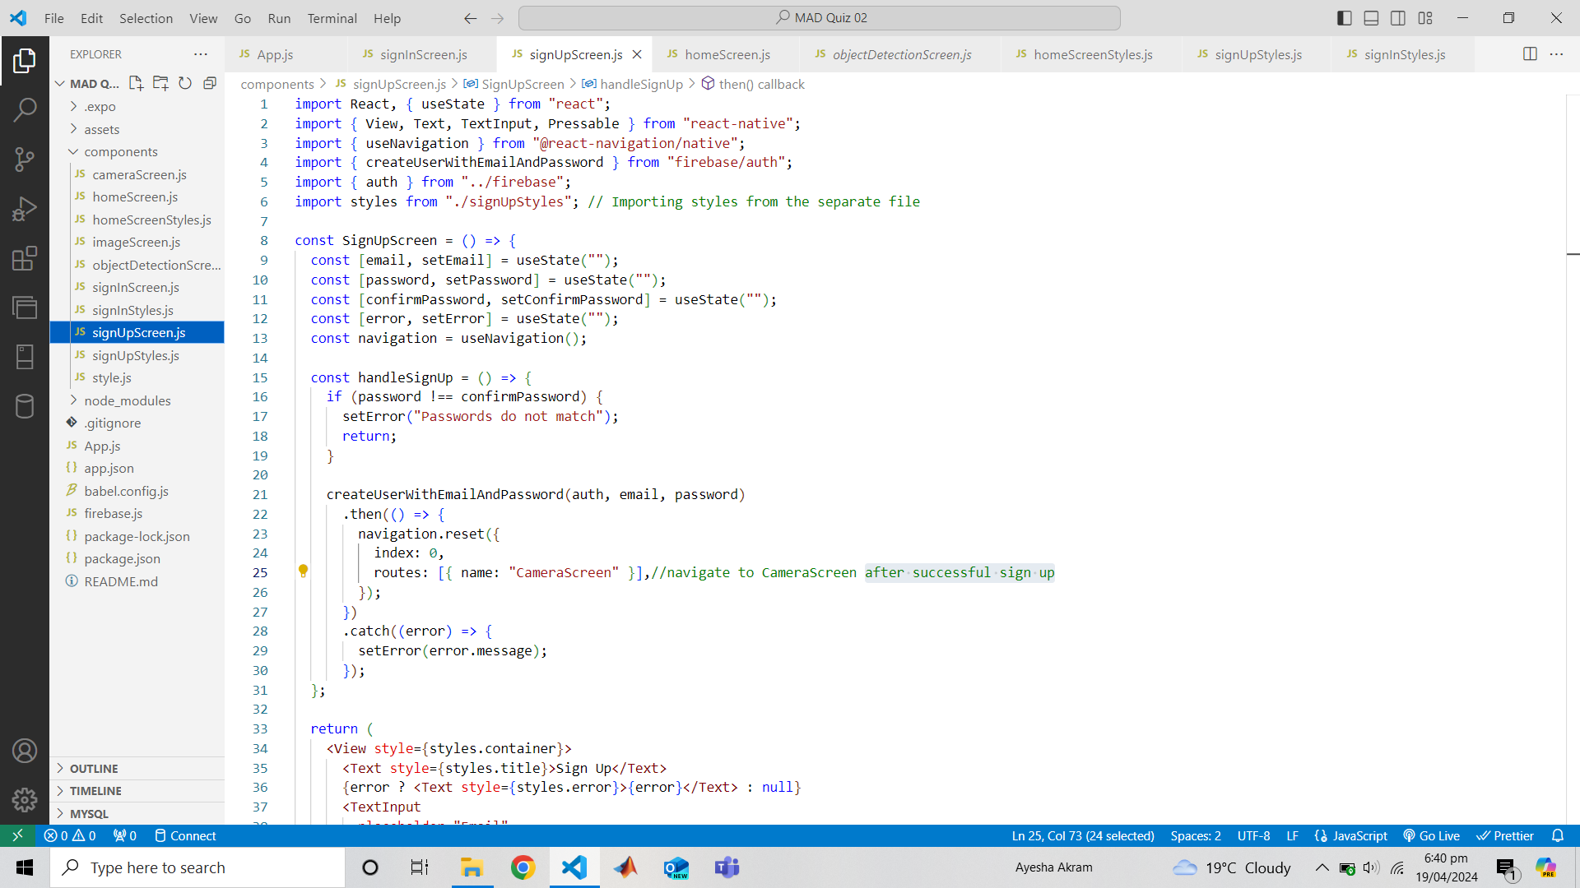

**signUpScreen.js**

**firebase.js**

**Outputs of Object Detection Model:**

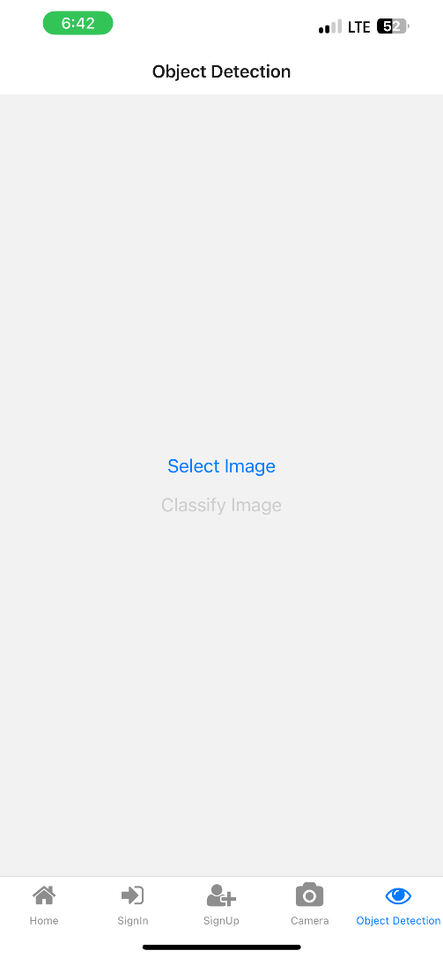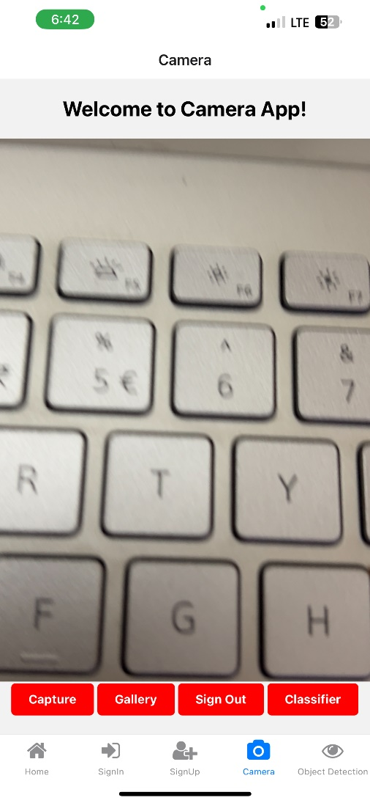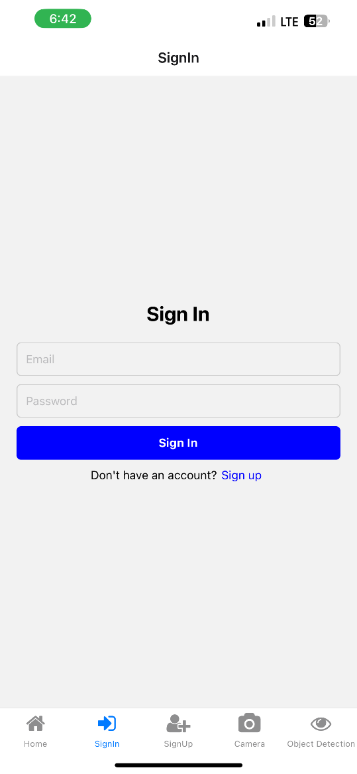

**Codes of QnA Model:**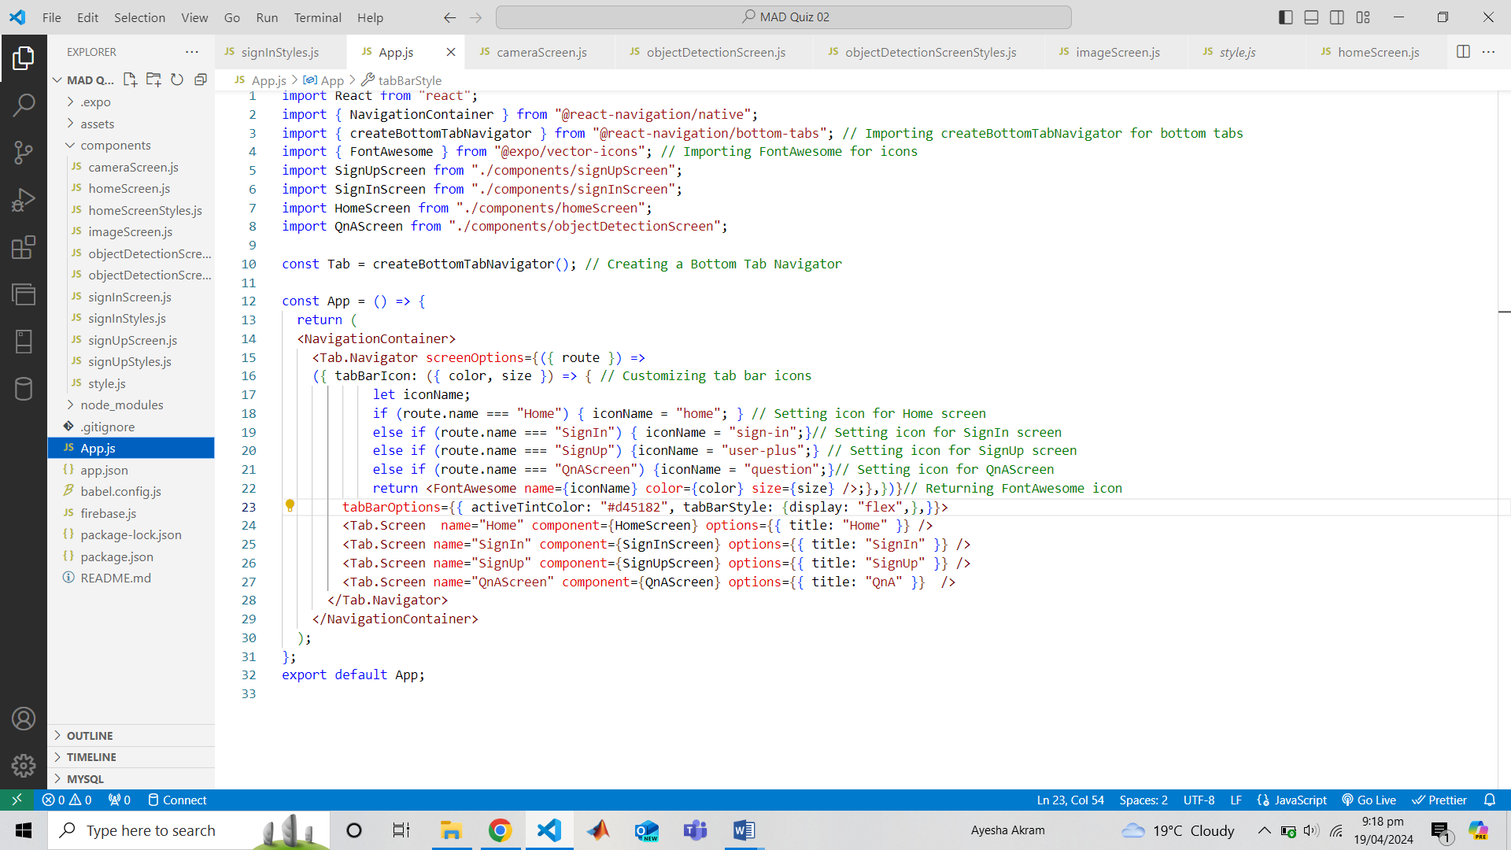

**App.js**

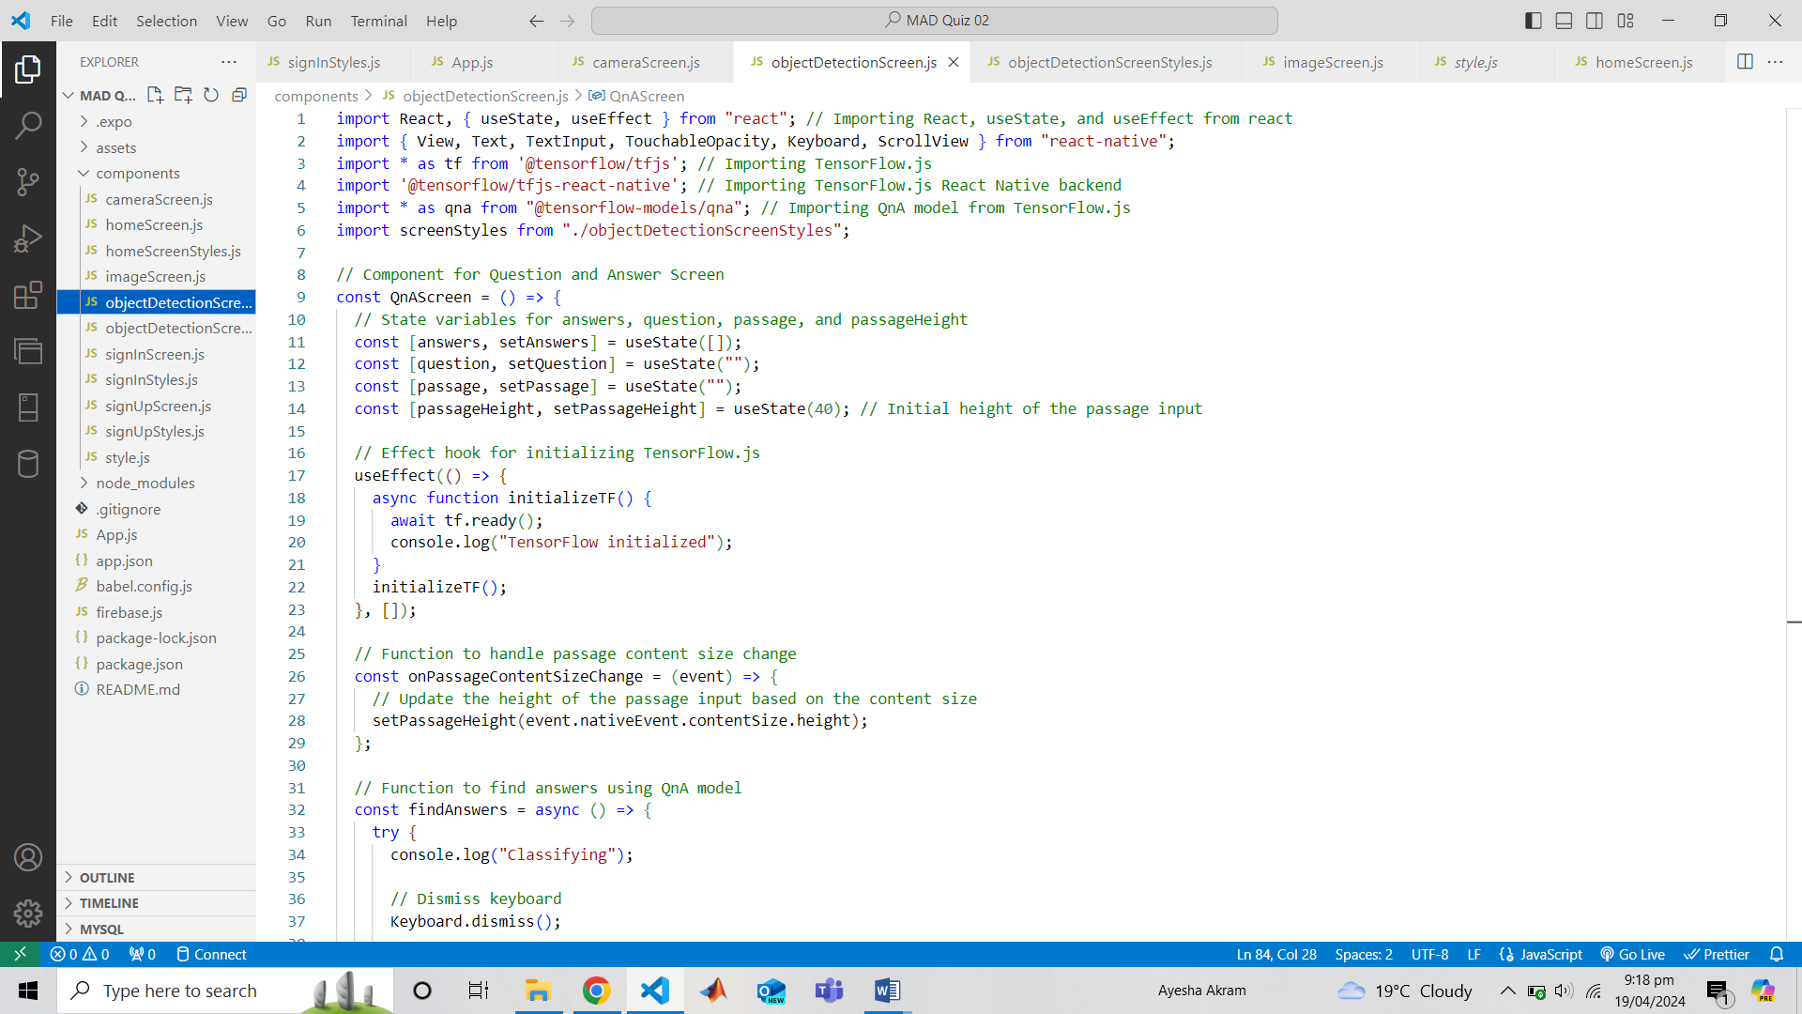

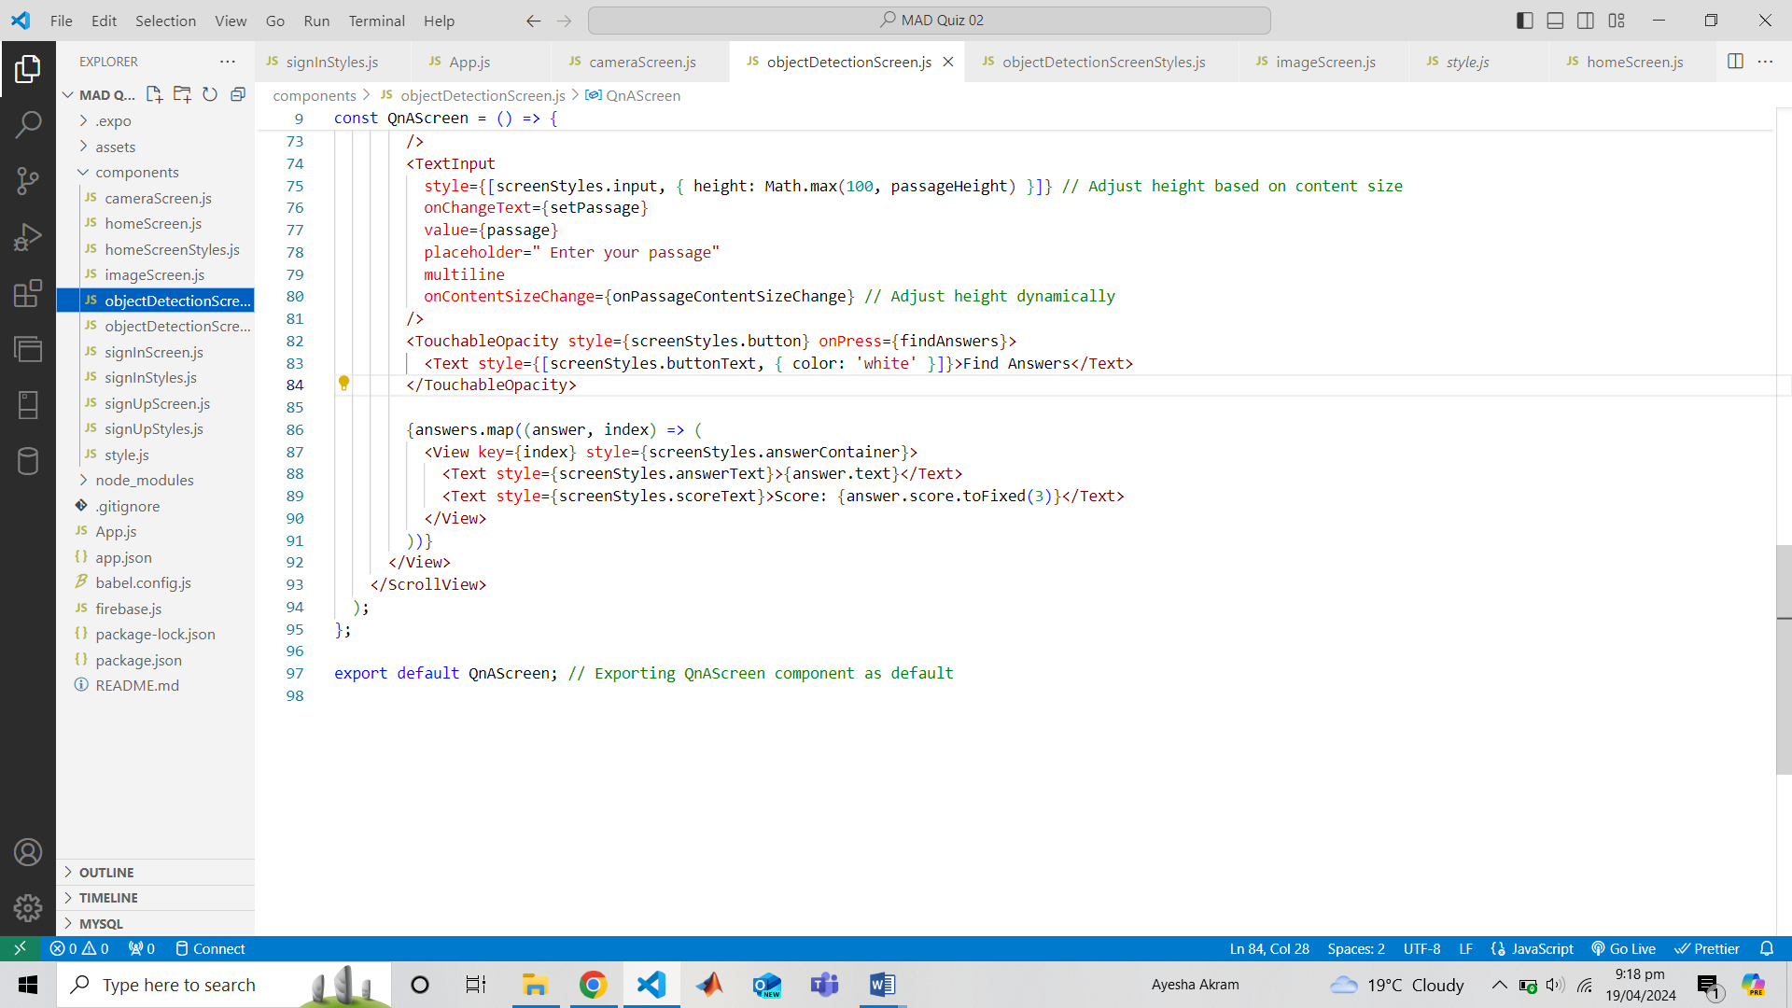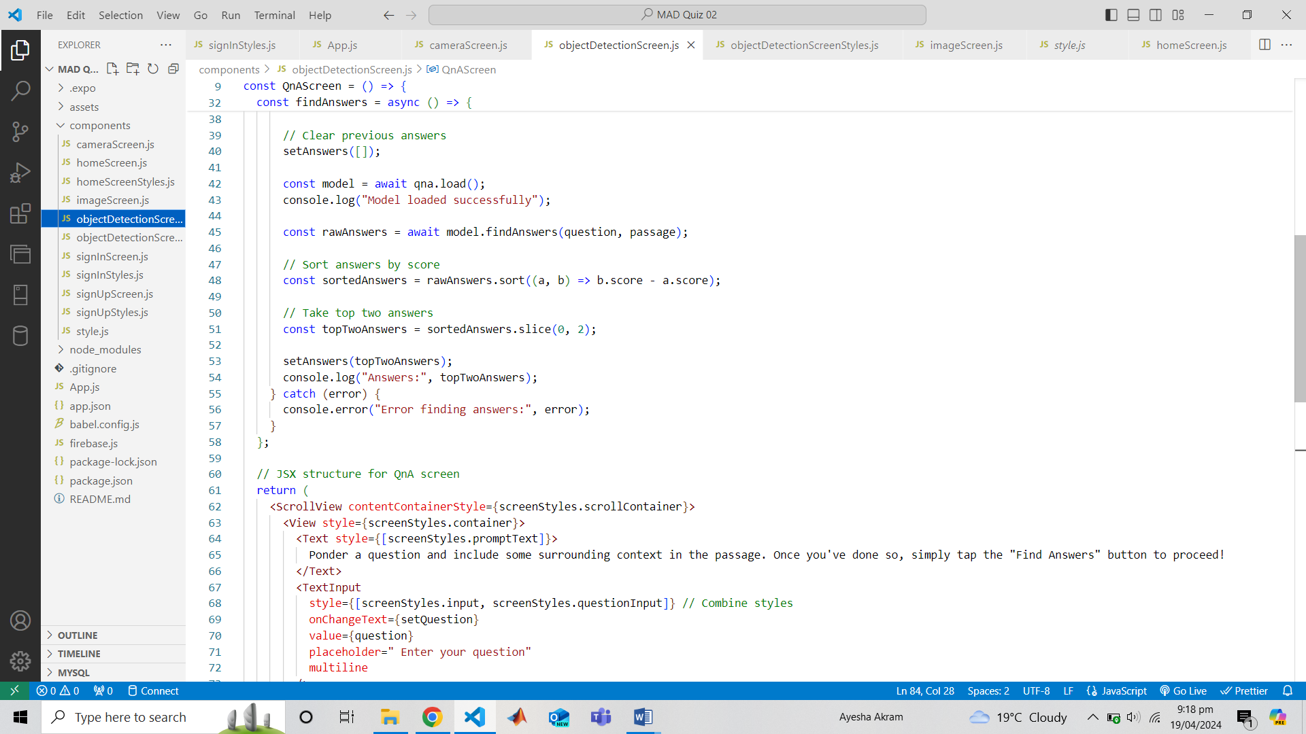

**objectDetectionScreen.js**

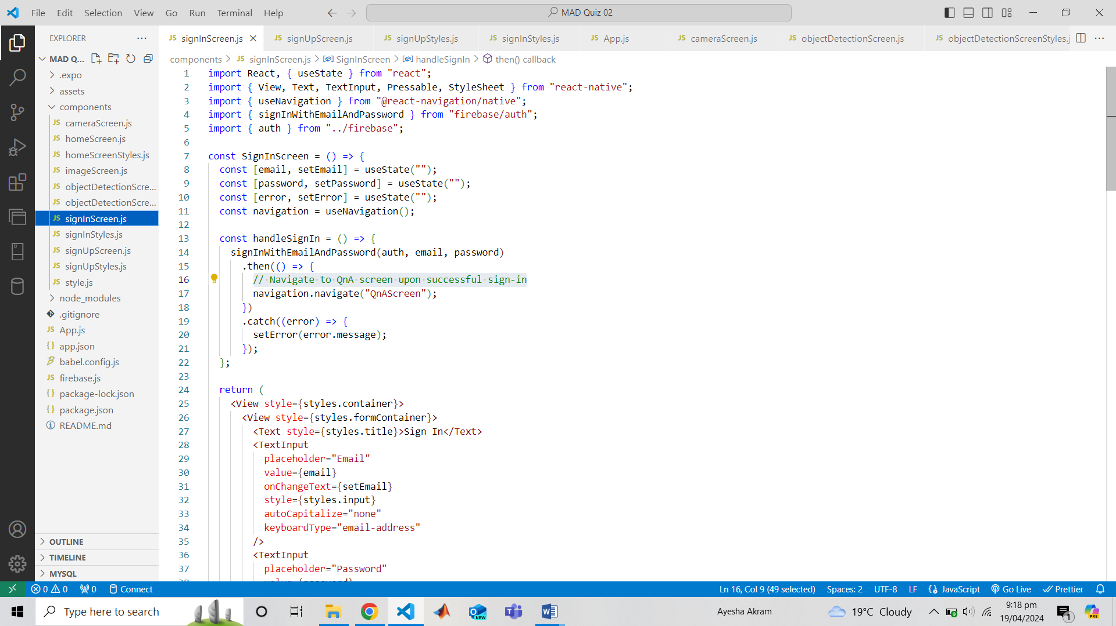

**signInScreen.js**

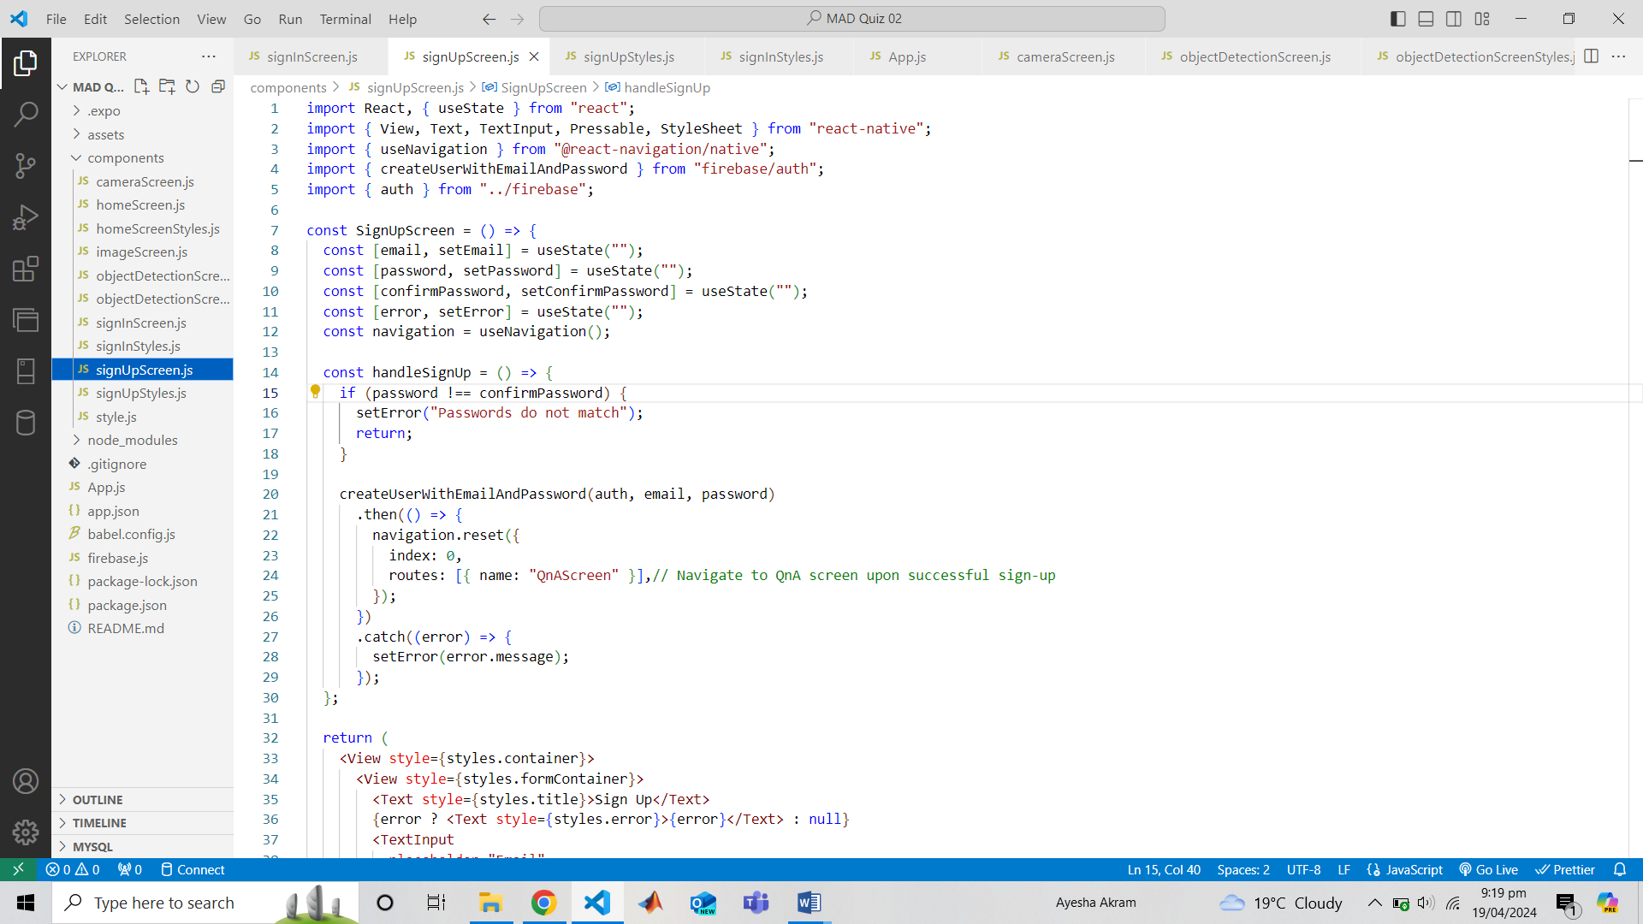

**signUpScreen.js**

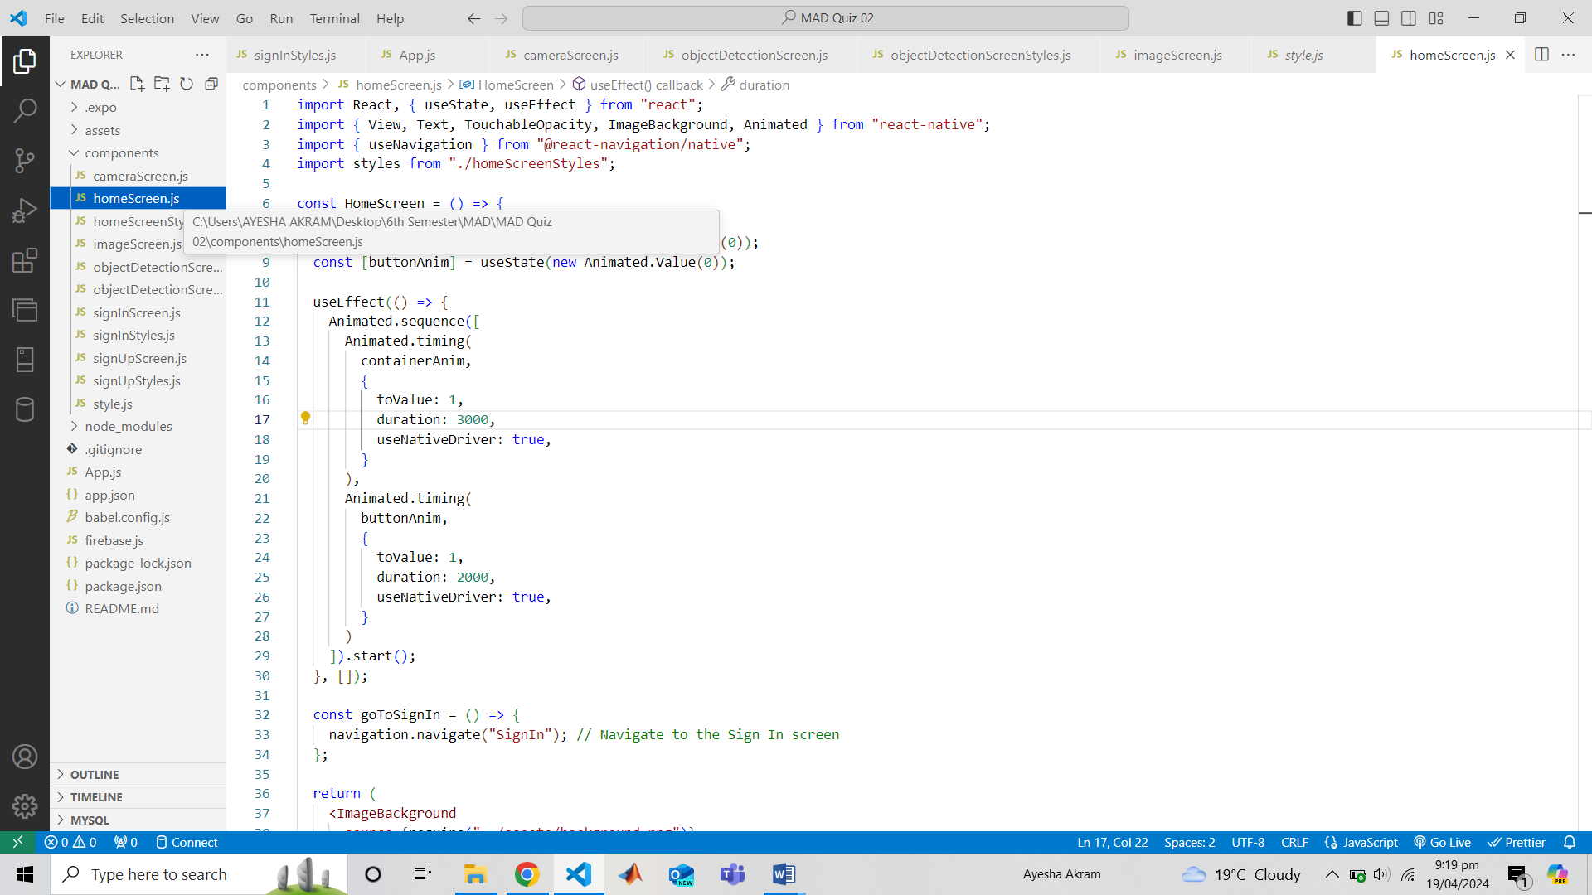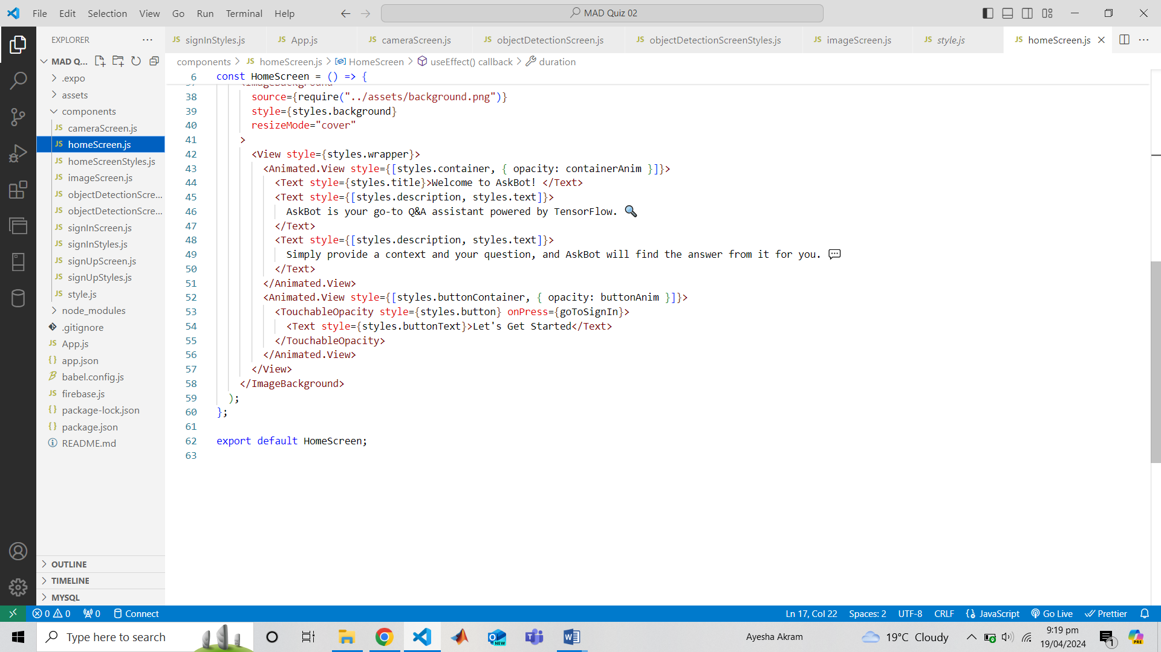

**homeScreen.js**

**Outputs of QnA Model:**

